**HARDNESS OF WATER PH VALUE AND ALKALINITY**

A Lab project work submitted to

K L University under the partial fulfillment of

B.Tech (1 Year) during 2017-18

By

**K.V.SAI TEJA**

**170040351**

Under the guidance of

**Dr. Shanmukh Kumar**



**K.L. UNIVERSITY**

**Green fields, Vaddeswaram, Guntur Dist**.522502

DECLARATION

I declare that the project work entitled “**Hardness of water and PH of a given solution and alkalinity** ” was carried out by **K.V.SAI TEJA-170040351** during ______________ 2018, and this work is not the same as that of any other and has not been submitted for award of any other degree/diploma.

Place: Signature of the Student

Date:



**K.L. UNIVERSITY**

**Green fields, Vaddeswaram, Guntur Dist**.

CERTIFICATE

This is certify that this project work entitled “**Hardness of water and PH of a given solution and alkalinity**” By **K.V.SAI TEJA-170040351** is a bonified work carried out by them in Department of Chemistry.

Project supervisor Head of the Department

ACKNOWLEDGEMENT

We express my sincere gratitude to -------------------------------------------------for encouraging and guiding us to undertake this project work.

We express my deep sense of gratitude to --------------------------------and our beloved course lecturers of department for their encouragement.

Place:

Date:

CONTENTS

1. Introduction

2. Aim

3. Methodology

4. Results and discussion

5. Conclusion

**INTRODUCTION**

**PH:**

In [chemistry](https://en.wikipedia.org/wiki/Chemistry), **pH**  (potential of hydrogen) is a numeric scale used to specify the [acidity](https://en.wikipedia.org/wiki/Acidity) or [basicity](https://en.wikipedia.org/wiki/Basicity) of an [aqueous solution](https://en.wikipedia.org/wiki/Aqueous_solution). It is approximately the negative of the base 10 [logarithm](https://en.wikipedia.org/wiki/Logarithm) of the [molar concentration](https://en.wikipedia.org/wiki/Molar_concentration), measured in units of [moles](https://en.wikipedia.org/wiki/Mole_(unit)) per liter, of [hydrogen ions](https://en.wikipedia.org/wiki/Hydrogen_ion). More precisely it is the negative of the base 10 logarithm of the [activity](https://en.wikipedia.org/wiki/Activity_(chemistry)) of the hydrogen ion.[[1]](https://en.wikipedia.org/wiki/PH#cite_note-Bates-1) Solutions with a pH less than 7 are acidic and solutions with a pH greater than 7 are [basic](https://en.wikipedia.org/wiki/Basic_(chemistry)). [Pure water](https://en.wikipedia.org/wiki/Properties_of_water) is neutral, at pH 7 (25 °C), being neither an acid nor a base. Contrary to popular belief, the pH value can be less than 0 or greater than 14 for very strong acids and bases respectively.[[2]](https://en.wikipedia.org/wiki/PH#cite_note-2)

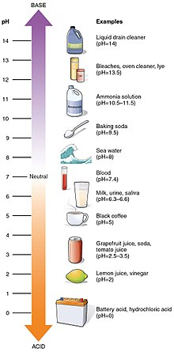

**DETERMINATION OF PH BY USING GLASS AND CALOMEL ELECTRODES:**

GLASS ELECTRODE:

It consists of a thin walled glass bulb made up of a special thin glass membrane in which 0.1M HCl solution is taken. A Pt or Ag wire coated with AgCl2 is placed in the solution for electrical contact. When glass electrode is placed in test solution whose Ph is to be determined,due to the difference in [H+] ion concentration inside and outside of glass bulb a sort of potential will develop across glass bulb The potential is generally proportional to the Ph of solution.

CALOMEL ELECTRODE:

It consists of a long glass tube with 2 arms out of which one will act as a bridge at the bottom of which Mercury+Mercurous chloride paste above that saturated KCl solution and a Pt wire is placed in Hg for electrical contact.

E0 calomel=+0.2422V

PROCEDURE:

Glass and calomel electrodes are connected externally through voltameter and internally by a salt bridge and glass electrode is placed in test solution whose ph is to be determined. Glass electrode is anode and calomel electrode is cathode.

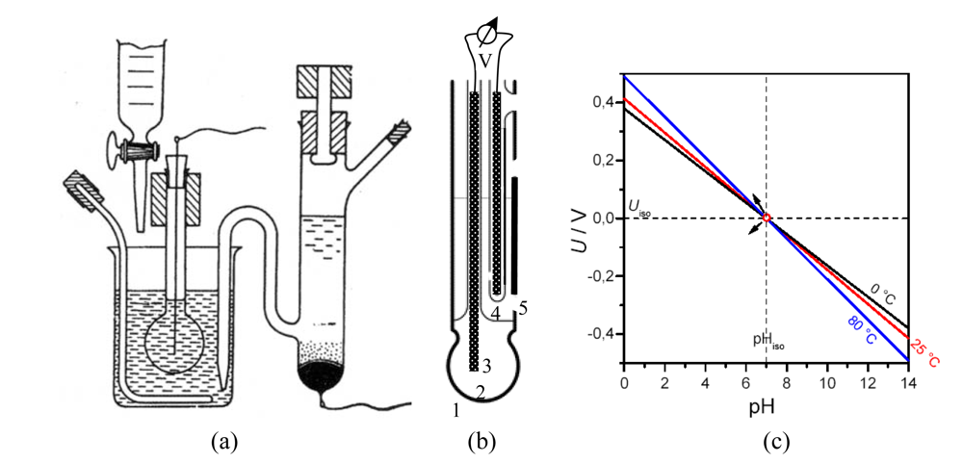

**HARDNESS OF THE WATER:**..

**Hard water** is [water](https://en.wikipedia.org/wiki/Water) that has high [mineral](https://en.wikipedia.org/wiki/Mineral) content (in contrast with "[soft water](https://en.wikipedia.org/wiki/Soft_water)"). Hard water is formed when water [percolates](https://en.wikipedia.org/wiki/Percolation) through deposits of [limestone](https://en.wikipedia.org/wiki/Limestone) and [chalk](https://en.wikipedia.org/wiki/Chalk) which are largely made up of [calcium](https://en.wikipedia.org/wiki/Calcium) and [magnesium](https://en.wikipedia.org/wiki/Magnesium) carbonates.

Hard [drinking water](https://en.wikipedia.org/wiki/Drinking_water) may have moderate health benefits, but can pose critical and grieveous problems in industrial settings, where water hardness is monitored to avoid costly breakdowns in [boilers](https://en.wikipedia.org/wiki/Boiler), [cooling towers](https://en.wikipedia.org/wiki/Cooling_tower), and other equipment that handles water. In domestic settings, hard water is often indicated by a lack of [foam](https://en.wikipedia.org/wiki/Foam) formation when [soap](https://en.wikipedia.org/wiki/Soap) is agitated in water, and by the formation of [limescale](https://en.wikipedia.org/wiki/Limescale) in kettles and water heaters.[[1]](https://en.wikipedia.org/wiki/Hard_water#cite_note-who-1) Wherever water hardness is a concern, [water softening](https://en.wikipedia.org/wiki/Water_softening) is commonly used to reduce hard water's adverse effects.

Hard water is the soap consuming capacity of water.

Test to detect hardness of water:

2 C17H35COONa+ CaCl2 → (C17H35COO)2Ca +2NaCl.

Those cations which forms insoluble soap on shaking with soap solution gives hardness of water.

TYPES OF HARDNESS OF WATER:

Based on the type of salt present in water hardness is classified into 2 types.

1. Temporary hardness.

2. Permanent hardness.

**TEMPORARY HARDNESS:**

Temporary hardness is a type of water hardness caused by the presence of [dissolved](https://en.wikipedia.org/wiki/Dissolution_(chemistry)) [bicarbonate](https://en.wikipedia.org/wiki/Bicarbonate) [minerals](https://en.wikipedia.org/wiki/Mineral) ([calcium bicarbonate](https://en.wikipedia.org/wiki/Calcium_bicarbonate) and [magnesium bicarbonate](https://en.wikipedia.org/wiki/Magnesium_bicarbonate)). When dissolved, these minerals yield calcium and magnesium [cations](https://en.wikipedia.org/wiki/Cations) (Ca2+, Mg2+) and carbonate and [bicarbonate](https://en.wikipedia.org/wiki/Bicarbonate) [anions](https://en.wikipedia.org/wiki/Anion) (CO32−, HCO3−). The presence of the metal cations makes the water hard. This "temporary" hardness can be reduced either by boiling the water, or by the addition of [lime](https://en.wikipedia.org/wiki/Lime_(mineral)) ([calcium hydroxide](https://en.wikipedia.org/wiki/Calcium_hydroxide)) through the process of [lime softening](https://en.wikipedia.org/wiki/Lime_softening).[[4]](https://en.wikipedia.org/wiki/Hard_water#cite_note-4) Boiling promotes the formation of carbonate from the bicarbonate and precipitates calcium carbonate out of solution, leaving water that is softer upon cooling.

It is also called as carbonate hardness or alkaline hardness.

Ca(HCO3) 🡪 CaCo3+CO2+H2O

Mg(HCO3) 🡪 MgCo3+CO2+H2O

**PERMANENT HARDNESS:**

Permanent hardness is hardness (mineral content) that cannot be removed by [boiling](https://en.wikipedia.org/wiki/Boiling). When this is the case, it is usually caused by the presence of [calcium sulphate](https://en.wikipedia.org/wiki/Calcium_sulphate)/[calcium chloride](https://en.wikipedia.org/wiki/Calcium_chloride) and/or [magnesium sulphate](https://en.wikipedia.org/wiki/Magnesium_sulphate)/[magnesium chloride](https://en.wikipedia.org/wiki/Magnesium_chloride) in the water, which do not precipitate out as the [temperature](https://en.wikipedia.org/wiki/Temperature) increases. Ions causing permanent hardness of water can be removed using a water softener, or [ion exchange column](https://en.wikipedia.org/wiki/Ion_exchange),Lime Soda process,Zeolite process

This is mainly due to CaCl2,CaSO4,Ca(OH)2,MgCl2,Mg(SO)4,Mg(NO3)2,Mg

This is also called as Non Carbonate hardness or Non Alkaline hardness.

**TOTAL HARDNESS:**

Total hardness = Permanent Hardness + Temporary Hardness.

**CaCO3 EQUIVALENTS:**

The concentration of hardness is expressed in the terms of CaCO3 equivalents because it is insoluble in H2O.

Molecular weight of CaCO3 is 100 which is the round figure for multiplication and division of concentration.

((Wt of hardness producing substance(mg/l))*100)

**DIVIDE BY** (M.W of hardness producing substance)

**ALKALINITY:**

Alkalinity is the acid neutralizing or buffering capacity of water.

Alkalinity of water is due to the presence of OH-,HCO3-,CO3-2 ions or the combination of them.

Existence of OH- and HCO3- together in any water sample is ruled out and hence existence of all 3 ions together is also ruled out.

It is based upon neutralization reaction, acid base titration falls under volumetric analysis. In the titration we use 2 indicators (methyl orange and phenolphthalein).

**CHEMISTRY OF TITRATION:**

**OH- + H+ 🡪 H2O**

**CO3-2 + H+ 🡪 HCO3-**

**HCO3- + H+ 🡪 H2O + CO2**

**AIM**

To determine the hardness of water and alkalinity and PH of a solution by C-programming.

**METHODOLOGY**

#include<stdio.h>

#include<math.h>

int main(){

int a;

printf("select a number for the task you want\n");

printf("1:ph detemination\n 2:hardness detemination\n 3:alkalinity determination\n 4:emf of the cell\n");

scanf("%d",&a);

if(a==1){

float e,ph;

printf("enter the value of emf of the cell\n");

printf("The e value of the cell ust be less than 0.4\n");

scanf("%f",&e);

ph=(e+0.6994-0.2422)/0.0591;

printf("The required ph value is:%f\n",ph);

}

if(a==4){

float c,a;

printf("enter the e0 value of cathode and anode\n");

scanf("%f %f",&c,&a);

printf("the e0 vaue of cell is %f\n",c-a);

}

if(a==2){

float mh,vh,ve,me,mh1,vh1,mh2,ve1,ve2,mho,vho,ai,vi;

printf("enter the amount and volume of impurity\n");

scanf("%f %f",&ai,&vi);

mh=ai*10/vi;

printf("The molarity of the standard hard water is %f\n",mh);

printf("enter the value of volume of shw and the volume of EDTA\n");

scanf("%f %f",&vh,&ve);

me=(mh*vh)/ve;

printf("The molarity of EDTA is %f\n",me);

printf("enter the volume the required water sample and volume of EDTA\n");

scanf("%f %f",&vh1,&ve1);

mh1=me*ve1/vh1;

printf("The molarity of water titrating with edta is %f\n",mh1);

printf("enter the volume of edta\n");

scanf("%f",&ve2);

mh2=ve2*me/vh1;

printf("The molarity of water after boiling and titrating with edta is %f\n",mh2);

printf("The Total Hardness of water is %f ppm of caco3 \n",mh1*100000);

printf("The permanent Hardness of water is %f ppm of caco3 \n",mh2*100000);

printf("The permanent Hardness of water is %f ppm of caco3 \n",100000*(mh1-mh2));

}

if(a==3){

int p,m;

printf("Enter the values of p and m\n");

scanf("%d %d",&p,&m);

if(p==0&&m==0)

printf("alkalinity is absent\n");

else if(p==0&&m!=0)

printf("alkalinity is due to HCO3- ions\n");

else if(p==m)

printf("alkalinity is due to OH- ions\n");

else if(p==m/2)

printf("alkalinity is due to CO3-2 ions\n");

else if(p>m/2)

printf("alkalinity is due to CO3-2 and OH- ions\n");

else if(p<m/2)

printf("alkalinity is due to HCO3- and CO3-2 ions\n");

}

return 0;}

**RESULTS AND DISCUSSION**

**INPUT 1:**

1

0.2

**OUTPUT 1:**

11.120135

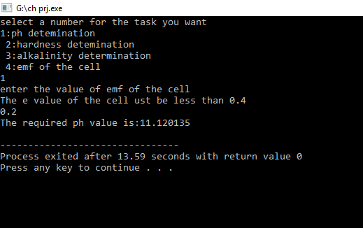

**INPUT 2**

2

15 1000

20 25

100 18

12

**OUTPUT 2:**

The Total Hardness of water is 2159.999756 ppm of caco3

The permanent Hardness of water is 1440.000000 ppm of caco3

The permanent Hardness of water is 719.999878 ppm of caco3

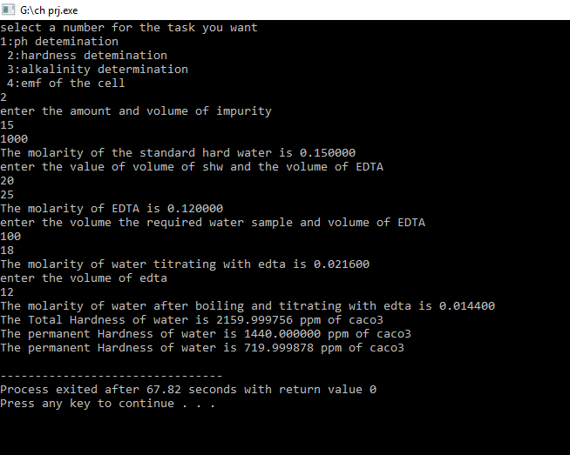

**INPUT 3:**

3

4 2

**OUTPUT 3:**

alkalinity is due to CO3-2 and OH- ions

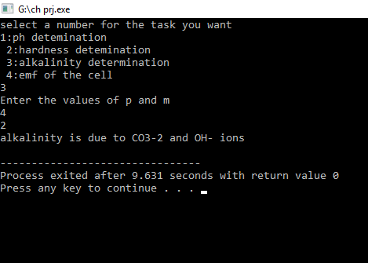

**INPUT 4:**

4

0.7 0.2

**OUTPUT 4:**

the e0 vaue of cell is 0.500000

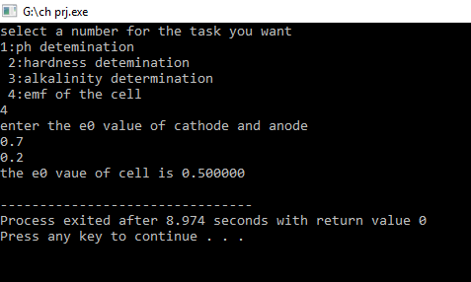

**CONCLUSION**

The ph value of an unknown solution and alkalinity and the hardness of the water can be calculated by using the following C programs .

So by using the above C programs we can easily calculate our requirements more efficiently and with less time complexity.

Thus by calculating chemical requirements by computing leads to the new era of develepments with a more understandable way.

**Submitted by:**

**K.V. SAI TEJA**

**170040351**

**S22**

**R.NO 27**